|  |  |  |  |
| --- | --- | --- | --- |
| 1 | | 0.0 | |
| NUMERO DE FRONTERAS | | ENERGIA AGREGADA | |
|  | | | |
| NO | | 0 | |
| CONTRATO | | VENCIMIENTO CONTRATO | |
|  | | | |
| 259,310,331 | 92 | | 11,506,523 |
| INGRESO 2021 | DÍAS CERTIFICADOS 2021 | | ENERGIA RESPALDADA 2021 |

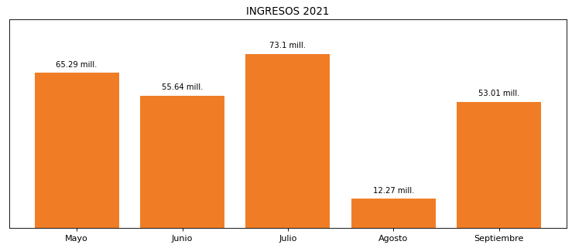

|  |
| --- |
| **FAMILIA MEDELLIN**  USUARIO |

|  |
| --- |
| **Camilo Bermudez**  Ejecutivo de cuenta |

|  |
| --- |
| **0**  PUNTO FOCAL |

|  |  |  |  |  |  |  |  |  |  |  |
| --- | --- | --- | --- | --- | --- | --- | --- | --- | --- | --- |
| **FRONTERA** | **COD SIC** | **PREDIO** | **FRT DDV** | **TIPO DDV** | **PROMEDIO** | **PRÓXIMA ACTUALIZACIÓN** | **MARGEN DE ERROR** | **ÚLTIMA PRUEBA DDV** | **DÍAS PARTICIPACIÓN** | **FECHA REFERENCIA PRÓXIMA PRUEBA DDV** |